

AMERICAN INTERNATIONAL UNIVERSITY–BANGLADESH (AIUB)
Dept. of Computer Science
Faculty of Science and Technology
CSC2210: OBJECT ORIENTED PROGRAMMING 2
Spring 2025-2026
Section: [K]
Project Report On
Freelancing Platform
Supervised By Dr. Md. Iftekharul Mobin

Submitted By:
Name | ID
1. MD. HISHAMUR RAHMAN | 24-57939-2
2. MD. TALIMUL ISLAM UTSHA | 23-52908-2
Obtained Marks for CO2 and CO3 (Description given in the following page)
Assessment  Criteria | Not Attended/ Incorrect (0) |  | Inadequate  (1-2) |  | Average  (3) | Good  (4) | Excellent  (5)
Evaluation Criteria (CO2) |  | Total = |  | Evaluation Criteria (CO3) |  |  | Total =
Requirement fulfillment |  |  |  | Organization of the application
Validation |  |  |  | Representation and Integration of Database
Verification |  |  |  | Graphical User Interface

CO2: Display and verify the mean of a real-life Project using the concepts of C# Graphical User Interface based environment with database integration to depict a desktop-based application.
Assessment  Criteria | Not Attended/ Incorrect (0) | Inadequate  (1-2) |  | Average  (3) |  | Good  (4) |  | Excellent  (5)
Evaluation Criteria | Evaluation Definition
Requirement fulfillment | Fails to demonstrate any understanding of real-life scenario-based project development or functional requirement identification. There is no attempt to depict a project or identify functional requirements accurately. |  | Demonstrates limited understanding of real-life scenario-based project development and functional requirement identification. The project depicted lacks coherence or relevance to real-life scenarios, and functional requirements are inaccurately identified or insufficiently described. |  | Presents a basic depiction of a real-life scenario-based project and identifies some functional requirements. However, the project lacks depth or complexity, and some functional requirements may be vaguely defined or missing key details. |  | Effectively demonstrates a realistic scenario-based project and accurately identifies most functional requirements. The project is well-developed with appropriate complexity, and functional requirements are clearly articulated with relevant details. |  | Exhibits an exceptional understanding of real-life scenario-based project development and accurately identifies all functional requirements. The project is meticulously developed with thorough attention to detail, reflecting a comprehensive understanding of Object-Oriented Programming project development activities.
Validation | Fails to demonstrate any understanding or implementation of validation forms in their system. There is no attempt to deal with data validation, and validation requirements are completely ignored or incorrectly applied. |  | Demonstrates limited understanding of validation forms and data validation techniques. While some attempt may be made to implement validation, it is incomplete or poorly executed, leading to inadequate handling of data validation. |  | Shows a basic understanding of validation forms and data validation techniques. They attempt to implement validation, but some aspects may be missing or incorrectly implemented, resulting in partial or inconsistent handling of data validation. |  | Effectively demonstrates the use of validation forms and implements data validation techniques. Validation is mostly accurate and comprehensive, ensuring the proper handling of data input and verification in the system. |  | Exhibits an exceptional understanding and implementation of validation forms and data validation techniques. Validation is meticulously implemented with thorough attention to detail, ensuring robust data validation procedures and contributing to the overall reliability and integrity of the system.
Verification | Fails to demonstrate any attempt to verify the system data or functional requirements. There is no evidence of understanding or implementation of verification processes, and data flow is not considered. |  | Demonstrates limited understanding of verification processes and data flow in the system. Verification attempts are incomplete or inaccurate, and there is insufficient consideration given to ensuring data integrity and functionality. |  | Shows a basic understanding of verification processes and attempts to verify system data. However, verification efforts may be inconsistent or lack thoroughness, and there may be gaps in ensuring proper functional requirements and data flow. |  | Identifies and verifies system data, ensuring proper functional requirements are met. Verification efforts are mostly accurate and thorough, with attention to ensuring data integrity and appropriate data flow within the system. |  | Exhibits an exceptional understanding of verification processes and meticulously verifies system data. Verification efforts are comprehensive and precise, with a keen focus on ensuring all functional requirements are met and maintaining proper data flow throughout the system.

CO3: Prepare and Explain a real life desktop based application synthesizing several component of C# along with development tools to adhere the given requirements.
Assessment  Criteria | Not Attended/ Incorrect (0) | Inadequate  (1-2) |  | Average  (3) |  | Good  (4) |  | Excellent  (5)
Evaluation Criteria | Evaluation Definition
Organization of the application | Fails to identify any suitable real time application or requirements for project development activities related to OOP. |  | Limited understanding about the project scopes and scenarios or identification of functional requirements. |  | Lacks depth or relevance to OOP project development activities and may contain inaccuracies. Real-life scenarios are mentioned, but the discussion lacks depth or clarity. |  | Consider and integrate the idea of several core aspects of the project along with relevance to real-life scenarios. Demonstrating a solid understanding of the application presentation. |  | Generalize and exhibits an exceptional understanding of project preparation according to a to real-life scenarios. Also contains proper and insightful identification of the system which is comprehensive and precise.
Representation and Integration of Database | Fails to identify and present any understanding or implementation of database. Also failed to integrate the data with the project itself. |  | Limited understanding of the database concepts or their proper way of using in a real time project. While some attempt may be made to implement but it is incomplete or poorly executed, leading to inadequate design. |  | Lacks depth or relevance to database integration with the application. Shows a basic understanding but some aspects may be missing or incorrectly implemented, resulting in partial or inconsistency. May lack proper normalization. |  | Integrate the database with the forms properly and implements it with proper validation which is mostly accurate and comprehensive, ensuring the proper handling of data input and verification along with general normalization. |  | Exhibits an exceptional understanding and implementation of database ensuring attention to detail, and robust data manipulation procedures and contributing to the overall clarity.
Graphical User Interface | Fails to present or prepare GUI based application interfaces. There is no evidence of creating or integrating such things according to their usefulness. |  | Limited understanding of graphical user interfaces. Lack of design knowledge. Very poor attempt to make such things which are currently obsolete or can’t be identified as coherent. |  | Shows a basic understanding of creating user interfaces. Most of them are interconnected but maybe some of them lack it. However, most of it can be described as user friendly. |  | Effectively identifies and meet the consider the simplicity. Design related works are mostly accurate and taken proper attention to ensuring a user-friendly coherent system. |  | Exhibits an exceptional work design following a high standard of simple and elegant work. Several controls and mechanism has been organized in a preferred way according to the coherent usage .

Table of Contents: Page no.

1. Chapter :01 (Introduction)---------------------------------------------------------------------- 03
2. Chapter :02(User Story)------------------------------------------------------------------------- 03
3. Chapter :03 (ER Diagram)---------------------------------------------------------------------- 05
4. Chapter :03 (SQL Queries)--------------------------------------------------------------------- 06
5. Chapter:04 (Screenshots) ---------------------------------------------------------------------- 09

- 1 Introduction

The Freelancing Platform System is a modern web-based application designed to connect companies with skilled freelancers in an efficient and structured digital environment. In today’s fast-growing online economy, organizations increasingly rely on freelance professionals to complete tasks quickly and cost-effectively. This system aims to provide a centralized platform where companies can post job opportunities and hire suitable employees, while freelancers can explore job listings based on their skills, interests, and availability.
The platform supports three main types of users: Admin (System Owner), Company, and Employee (Freelancer). Each user role has specific functionalities tailored to their needs. The Admin is responsible for managing the overall system, including monitoring user activities, handling transactions, maintaining platform integrity, and enforcing rules such as banning or removing users with poor ratings or misconduct. Additionally, the Admin earns a fixed commission percentage from each successful transaction conducted on the platform.Companies can create accounts, post job listings, review applications submitted by freelancers, and select the most suitable candidates. They can also manage ongoing projects, make secure payments, and provide ratings and feedback to employees after job completion. On the other hand, employees (freelancers) can browse available jobs, apply according to their interests and skills, track application status, complete assigned tasks, and receive payments and ratings from companies.
The system incorporates key features such as job management, application tracking, hiring processes, payment handling with commission calculation, and a two-way rating system to ensure transparency and trust between users. By integrating these functionalities, the platform enhances communication, improves workflow efficiency, and promotes a reliable freelancing ecosystem.Overall, the Freelancing Platform System serves as a comprehensive solution that simplifies the hiring process, supports flexible employment opportunities, and ensures secure and transparent transactions for all users involved.

1.2 Objective of the Project

The main objective of this project is to develop a web-based Freelancing Platform that connects companies and freelancers in a centralized system. The platform aims to simplify the process of job posting, job searching, hiring, and payment through an organized and user-friendly interface.Another key objective is to provide role-based functionalities for Admin, Company, and Employee users. The Admin can manage users, monitor transactions, and maintain system security. Companies can post jobs and hire suitable employees, while employees can browse jobs and apply according to their skills and interests.
The system also aims to ensure transparency and trust by implementing features such as a rating system, secure payment handling, and admin commission tracking. Overall, the project is designed to improve efficiency, reduce manual effort, and create a reliable digital freelancing environment.
2 . Feature List

2.1 ADMIN FEATURES (Simplified)
- As an admin, I want to manage users (ban or remove users)
- As an admin, I want to view all transactions
- As an admin, I want to view reports and ratings
- As an admin, I want to log out securely

2.2 COMPANY FEATURES
- As a company, I want to register and log in
- As a company, I want to post jobs
- As a company, I want to view job applications
- As a company, I want to hire employees
- As a company, I want to make payments to employees
- As a company, I want to rate employees
- As a company, I want to log out

2.3 EMPLOYEE FEATURES
- As an employee, I want to register and log in
- As an employee, I want to browse jobs
- As an employee, I want to apply for jobs
- As an employee, I want to view application status
- As an employee, I want to earn money from jobs
- As an employee, I want to receive ratings
- As an employee, I want to log out

3.ER DIAGRAM
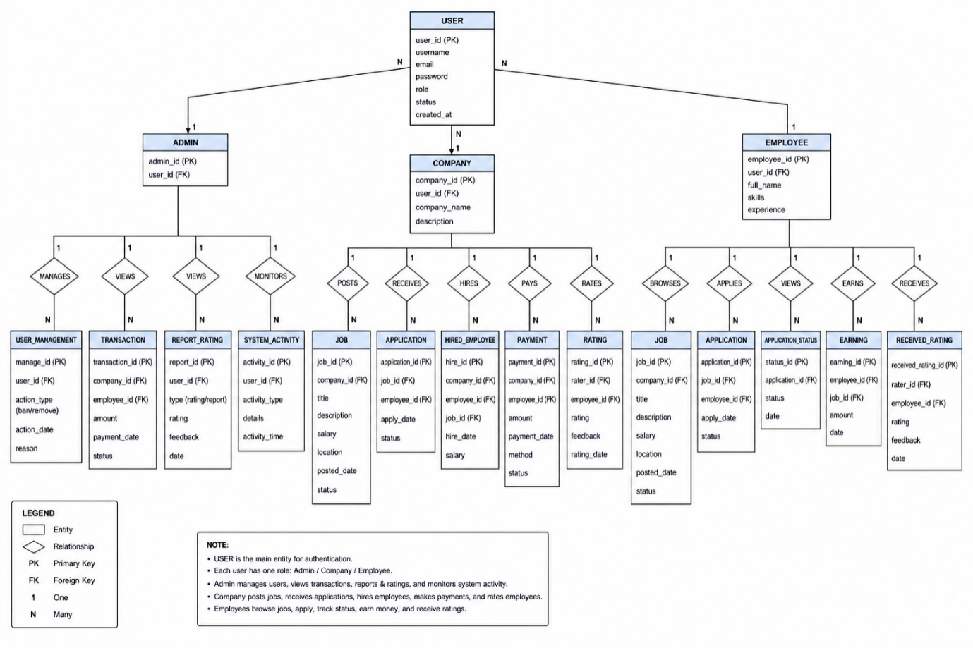

4. DATABASE SCHEMA:

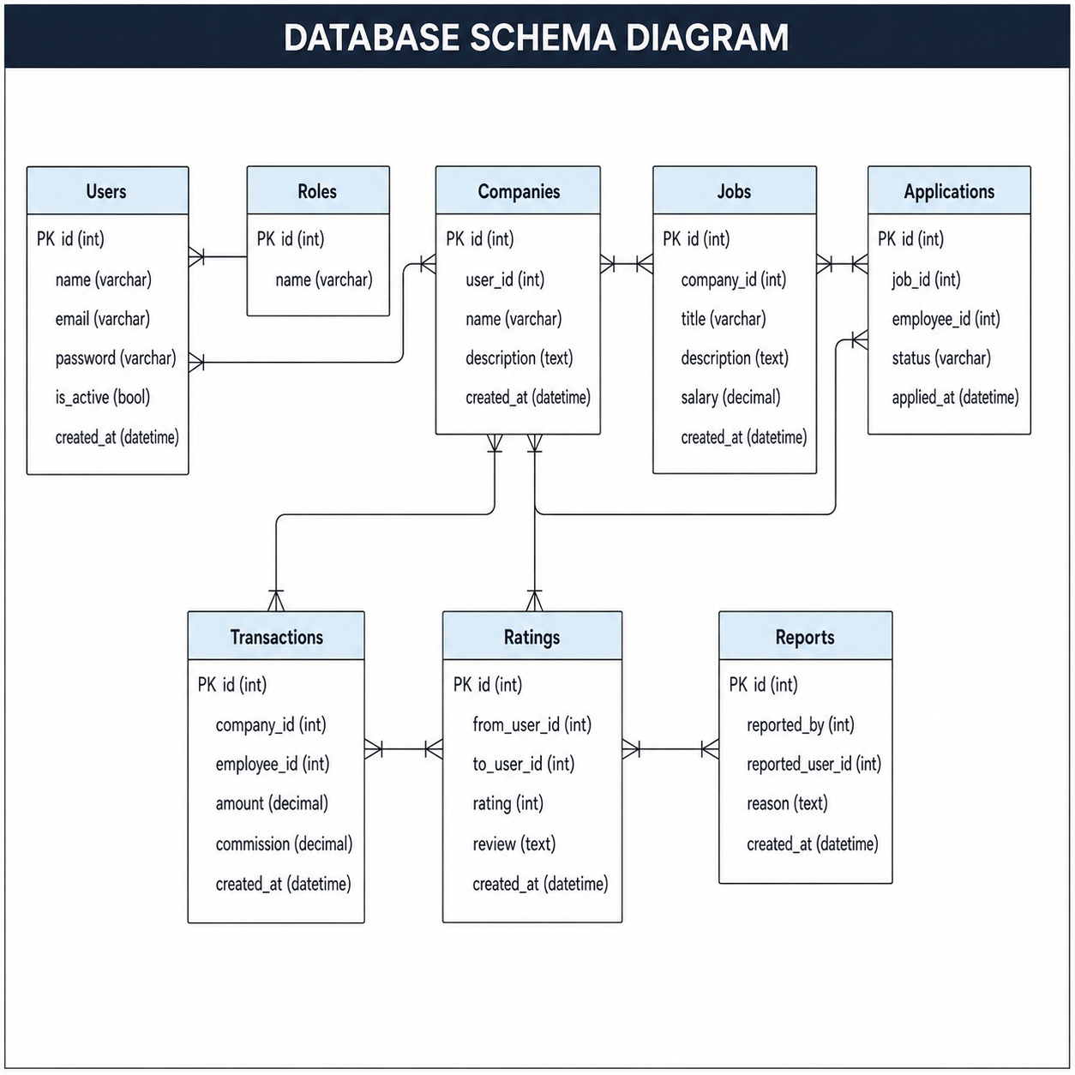

SQL Query:

CREATE DATABASE FreelancePlatformDB;
GO

USE FreelancePlatformDB;
GO

CREATE TABLE Users (
user_id INT PRIMARY KEY IDENTITY(1,1),
username VARCHAR(100),
email VARCHAR(100) UNIQUE,
password VARCHAR(255),
role VARCHAR(50), -- admin, client, freelancer
created_at DATETIME DEFAULT GETDATE()
);
CREATE TABLE Freelancer (
freelancer_id INT PRIMARY KEY IDENTITY(1,1),
user_id INT,
full_name VARCHAR(150),
skills TEXT,
experience INT,
hourly_rate DECIMAL(10,2),
FOREIGN KEY (user_id) REFERENCES Users(user_id)
);
CREATE TABLE Client (
client_id INT PRIMARY KEY IDENTITY(1,1),
user_id INT,
company_name VARCHAR(150),
FOREIGN KEY (user_id) REFERENCES Users(user_id)
);
CREATE TABLE Category (
category_id INT PRIMARY KEY IDENTITY(1,1),
name VARCHAR(100)
);
CREATE TABLE Gig (
gig_id INT PRIMARY KEY IDENTITY(1,1),
freelancer_id INT,
title VARCHAR(200),
description TEXT,
price DECIMAL(10,2),
delivery_time INT,
category_id INT,
FOREIGN KEY (freelancer_id) REFERENCES Freelancer(freelancer_id),
FOREIGN KEY (category_id) REFERENCES Category(category_id)
);
CREATE TABLE Job (
job_id INT PRIMARY KEY IDENTITY(1,1),
client_id INT,
title VARCHAR(200),
description TEXT,
budget DECIMAL(10,2),
created_at DATETIME DEFAULT GETDATE(),
FOREIGN KEY (client_id) REFERENCES Client(client_id)
);

CREATE TABLE Application (
application_id INT PRIMARY KEY IDENTITY(1,1),
job_id INT,
freelancer_id INT,
proposal TEXT,
status VARCHAR(50),
FOREIGN KEY (job_id) REFERENCES Job(job_id),
FOREIGN KEY (freelancer_id) REFERENCES Freelancer(freelancer_id)
);
CREATE TABLE Orders (
order_id INT PRIMARY KEY IDENTITY(1,1),
gig_id INT,
client_id INT,
freelancer_id INT,
total_amount DECIMAL(10,2),
status VARCHAR(50),
created_at DATETIME DEFAULT GETDATE(),
FOREIGN KEY (gig_id) REFERENCES Gig(gig_id),
FOREIGN KEY (client_id) REFERENCES Client(client_id),
FOREIGN KEY (freelancer_id) REFERENCES Freelancer(freelancer_id)
);
CREATE TABLE Payment (
payment_id INT PRIMARY KEY IDENTITY(1,1),
order_id INT,
amount DECIMAL(10,2),
payment_status VARCHAR(50),
payment_date DATETIME DEFAULT GETDATE(),
FOREIGN KEY (order_id) REFERENCES Orders(order_id)
);
CREATE TABLE Review (
review_id INT PRIMARY KEY IDENTITY(1,1),
order_id INT,
rating INT,
comment TEXT,
created_at DATETIME DEFAULT GETDATE(),
FOREIGN KEY (order_id) REFERENCES Orders(order_id)
);
CREATE TABLE Message (
message_id INT PRIMARY KEY IDENTITY(1,1),
sender_id INT,
receiver_id INT,
message_text TEXT,
sent_at DATETIME DEFAULT GETDATE(),
FOREIGN KEY (sender_id) REFERENCES Users(user_id),
FOREIGN KEY (receiver_id) REFERENCES Users(user_id)
);

Log in page:
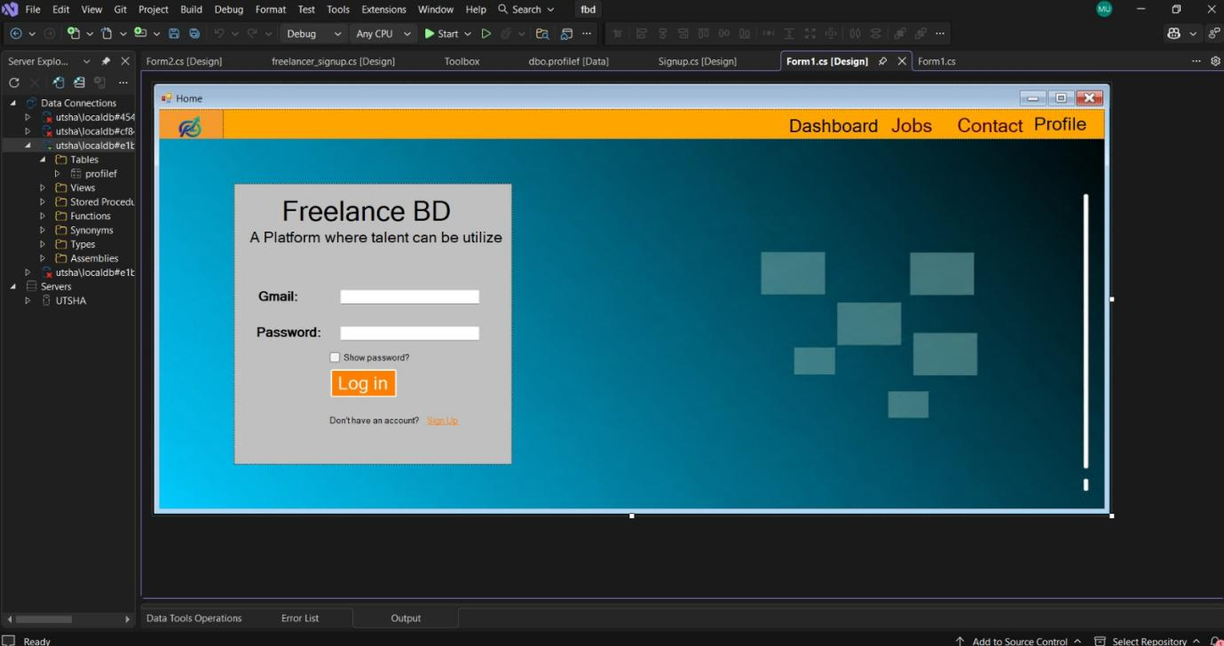

Customer sign up:

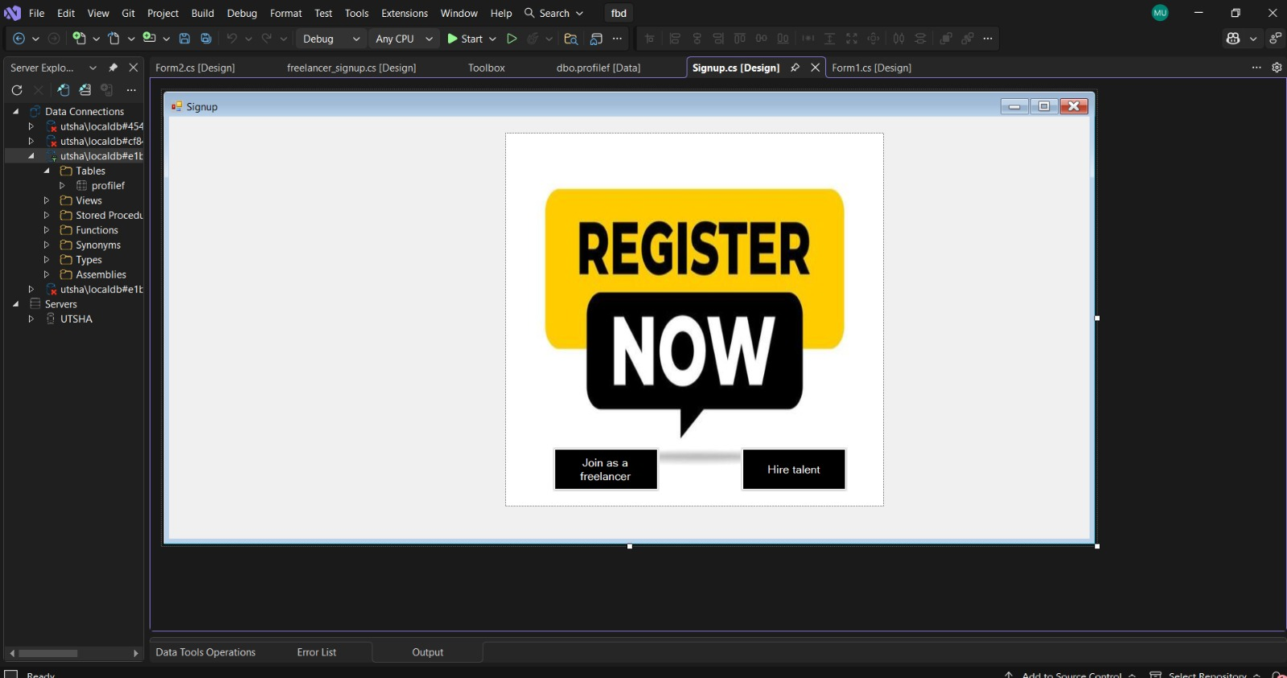

Freelancer sign up:



Information entry page:

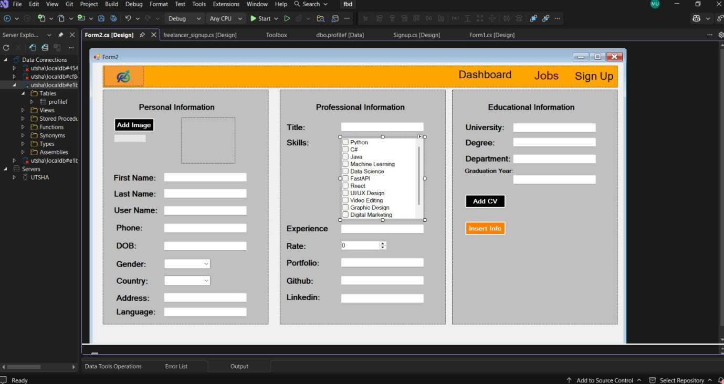

Profile:

